ENA EREC G99/NI
Type Test reference number |  | HERF-1600
Generating Unit technology |  | Photovoltaic Microinverter
System Supplier name |  | Xiamen E-star Energy Co., Ltd.
Address |  | 5F, Liantai Bldg, No.43 Huli Avenue, Xiamen, China
Tel | +86 15960215407 |  | Fax |  | -
E:mail | emily@estarpower.com |  | Web site |  | -
Registered Capacity, use  separate sheet if more than one connection option. | 1.6 per Unit | kW single phase, single, split or three phase system
 | NA | kW three phase
 | NA | kW two phases in three phase system
 | NA | kW two phases split phase system
Manufacturer compliance declaration. - I certify that all products supplied by the company with the above Type Tested Manufacturer’s reference number will be manufactured and tested to ensure that they perform as stated in this document, prior to shipment to site and that no site Modifications are required to ensure that the product meets all the requirements of EREC G99/NI.
Signed |  | On behalf of |  | Xiamen E-star Energy Co., Ltd.
Note that testing can be done by the Manufacturer of an individual component or by an external test house.
Where parts of the testing are carried out by persons or organizations other than the Manufacturer then that person or organization shall keep copies of all test records and results supplied to them to verify that the testing has been carried out by people with sufficient technical competency to carry out the tests.

Operating Range
 | Test 1:195.5V~47.5Hz, PF=1
HERF-1600 | 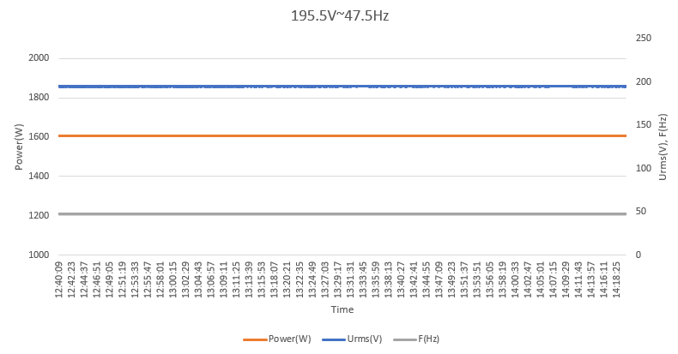
 | Test 2:253V~51.5Hz, PF=1
HERF-1600 | 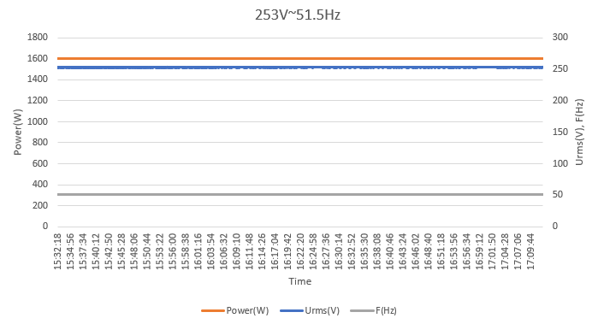
 | Test 3:253V~52Hz, PF=1
HERF-1600 | 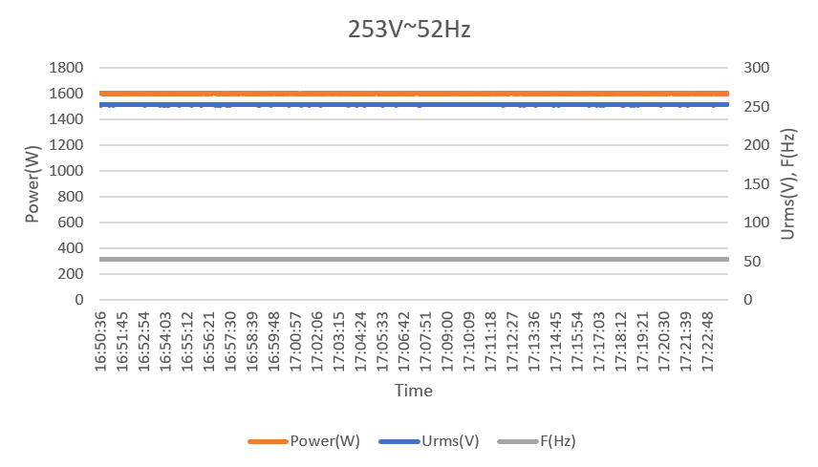

- Power Quality - Harmonic Generation
Generating Unit tested to BS EN 61000-3-12
Generating Unit rating per phase (rpp) |  |  | 1.6 | kW | Harmonic % =Measured Value (Amps) x 23/rating per phase (kVA)
Harmonic | At 45-55% of rated output |  | 100% of rated output |  | Limit in BS EN 61000-3-12
 | Measured Value MV in Amps | % | Measured Value MV in Amps | % | 1 phase | 3 phase
2 | 0.0023 | 0.0331 | 0.0073 | 0.1049 | 8% | 8%
3 | 0.0006 | 0.0086 | 0.0065 | 0.0934 | 21.6% | Not stated
4 | 0.0007 | 0.0101 | 0.0027 | 0.0388 | 4% | 4%
5 | 0.0005 | 0.0072 | 0.0083 | 0.1193 | 10.7% | 10.7%
6 | 0.0008 | 0.0115 | 0.0019 | 0.0273 | 2.67% | 2.67%
7 | 0.0045 | 0.0647 | 0.0053 | 0.0762 | 7.2% | 7.2%
8 | 0.0007 | 0.0101 | 0.0013 | 0.0187 | 2% | 2%
9 | 0.0031 | 0.0446 | 0.0037 | 0.0532 | 3.8% | Not stated
10 | 0.0003 | 0.0043 | 0.001 | 0.0144 | 1.6% | 1.6%
11 | 0.0017 | 0.0244 | 0.0024 | 0.0345 | 3.1% | 3.1%
12 | 0.0006 | 0.0086 | 0.0005 | 0.0072 | 1.33% | 1.33%
13 | 0.0011 | 0.0158 | 0.0021 | 0.0302 | 2% | 2%
THD |  | 2.4552 |  | 2.5053 | 23% | 13%
PWHD |  | 4.6922 |  | 4.788 | 23% | 22%

- Power Quality. Voltage fluctuations and Flicker
Test to BS EN 61000-3-11
 | Starting |  |  | Stopping |  |  | Running
 | dmax [%] | dc [%] | d(t) [%] | dmax [%] | dc [%] | d(t) [%] | Pst | Plt 2 hours
Measured Values at  test impedance | 0.15 | 0 | 0.004 | 0.15 | 0 | 0.004 | 0139 | 0139
Normalised to  standard impedance | 0.6 | 0 | 0.006 | 0.6 | 0 | 0.006 | 0139 | 0139
Normalised to required maximum impedance | 0.15 | 0 | 0.004 | 0.15 | 0 | 0.004 | 0139 | 0139
Limits set under  BS EN 61000-3-11 | 4% | 3.3% | 3.3% | 4% | 3.3% | 3.3% | 1 | 0.65
Test impedance | R | 0.4 |  | Ω | XI | 0.25 |  | Ω
Standard impedance | R | 0.24*  0.4^ |  | Ω | XI | 0.15*  0.25^ |  | Ω
Maximum impedance | R | 0.4 |  | Ω | XI | 0.25 |  | Ω
Test start date |  | 2024-01-04 |  | Test end date | 2024-01-04
Test location |  | SHANGHAI TESTING & INSPECTION INSTITUTE  FOR ELECTRICAL EQUIPMENT CO., LTD.

- Power quality. DC injection
Test power level | 10% | 55% | 100%
Recorded value(mA) | 0.879 | 1.846 | 3.571
as % of rated AC current | 0.01% | 0.03% | 0.05%
Limit | 0.25% | 0.25% | 0.25%

- Power Quality. Power factor
 | 216.2V | 230V | 253V | Measured at three voltage levels and at full output. Voltage to be maintained within ±1.5% of the stated level during the test.
Measured value | 0.9983 | 0.9988 | 0.9979
Limit (Leading) | >0.95 | >0.95 | >0.95
Limit (Lagging) | >0.98 | >0.98 | >0.98

- Protection. Frequency tests
Function | Setting |  | Trip test |  | “No trip tests”
 | Frequency | Time delay | Frequency | Time delay | Frequency /time | Confirm  no trip
U/F | 48Hz | 0.5s | 48Hz | 0.51s | 48.2Hz/ 25s | Confirmed
 |  |  |  |  | 47.8Hz/ 0.45s | Confirmed
O/F | 52Hz | 1.0s | 52Hz | 1.01s | 51.8Hz/120s | Confirmed
 |  |  |  |  | 52.2Hz/ 0.98s | Confirmed

- Protection. Voltage tests
Function | Setting |  | Trip test |  | “No trip tests”
 | Voltage | Time delay | Voltage | Time delay | Voltage /time | Confirm  no trip
U/V stage 1 | 195.5V | 3s | 195.4V | 3.01s | 199.5V/5s | Confirmed
U/V stage 2 | 138V | 2s | 138.1V | 2.01s | 142V/2.5s | Confirmed
 |  |  |  |  | 134V/1.98s | Confirmed
O/V stage 1 | 253V | 0.5s | 252.9V | 0.51s | 249V/5.0s | Confirmed
 |  |  |  |  | 257V/0.45s | Confirmed

- Power Park Modules - Protection – Loss of Mains test
Note: Inverter tested according to BS EN 62116.
Test Power and  imbalance | 33%  -5% Q  Test 22 | 66%  -5% Q  Test 12 | 100%  -5% P  Test 5 | 33%  +5% Q  Test 31 | 66%  +5% Q  Test 21 | 100%  +5% P  Test 10
Trip time. Limit is 0.5s | 103.1ms | 121.5ms | 157.8ms | 104.5ms | 131.3ms | 166.3ms

- Loss of Mains Protection, Vector Shift Stability test and RoCoF Stability test
 | Start Frequency | Change | End Frequency | Confirm no trip
Positive Vector Shift | 49.5Hz | +50 degrees |  | Confirmed
Negative Vector Shift | 50.5Hz | - 50 degrees |  | Confirmed
 | Ramp range | Test frequency ramp | Test Duration | Confirm no trip
Positive Frequency drift | 49Hz to 51Hz | +0.95Hz/sec | 2.1s | Confirmed
Negative Frequency drift | 51Hz to 49Hz | -0.95Hz/sec | 2.1s | Confirmed

- Limited Frequency Sensitive Mode – Over frequency test
Active Power response to rising frequency/time plots are attached if frequency injection tests are undertaken in accordance with Annex A.8.2.4
Test sequence at Registered Capacity >80% | Measured Active  Power Output (W) | Frequency (Hz) | Primary Power  Source | Active Power  Gradient
Step a) 50.00Hz ±0.01Hz | 1601.75 | 50 |  | -
Step b) 50.25Hz ±0.01Hz | 1583.82 | 50.25 |  | -
Step c) 50.70Hz ±0.10Hz | 1227.72 | 50.7 |  | -
Step d) 51.15Hz ±0.05Hz | 861.80 | 51.15 |  | -
Step e) 50.70Hz ±0.10Hz | 1226.84 | 50.7 |  | -
Step f) 50.25Hz ±0.05Hz | 1582.16 | 50.25 |  | -
Step g) 50.00Hz ±0.01Hz | 1600.39 | 50 |  | -
Test sequence at Registered Capacity 40%~60% | Measured Active  Power Output (W) | Frequency (Hz) | Primary Power  Source | Active Power  Gradient
Step a) 50.00Hz ±0.01Hz | 802.80 | 50 |  | -
Step b) 50.25Hz ±0.05Hz | 775.68 | 50.25 |  | -
Step c) 50.70Hz ±0.10Hz | 413.13 | 50.7 |  | -
Step d) 51.15Hz ±0.05Hz | 51.32 | 51.15 |  | -
Step e) 50.70Hz ±0.10Hz | 414.20 | 50.7 |  | -
Step f) 50.00Hz ±0.01Hz | 776.54 | 50.25
Step g) 50.25Hz ±0.05Hz | 801.28 | 50

- Protection. Re-connection timer
Test should prove that the reconnection sequence starts in no less than 20s for restoration of voltage and frequency to within the stage 1 settings of table 10.5.7.1
Time delay setting | Measured  delay | Checks on no reconnection when voltage or frequency is brought to just outside stage 1 limits of table 10.5.7.1.
60s | 90s | At 257V | At 191.5V | At 47.9Hz | At 52.1Hz
Confirmation that the Generating Unit does not re-connect. |  | Confirmed | Confirmed | Confirmed | Confirmed

- Fault level contribution
For machines with electro-magnetic output |  |  | For Inverter output
Parameter | Symbol | Value | Time after fault | Volts | Amps
Peak Short Circuit current | ip | N/A | 20ms | 19.31V | 0.0662A
Initial Value of aperiodic current | A | N/A | 100ms | 12.13V | 0.0452A
Initial symmetrical short-circuit current* | Ik | N/A | 250ms | 7.5V | 0.0314A
Decaying (aperiodic) component of short circuit current* | iDC | N/A | 500ms | 4.31V | 0.0215A
Reactance/Resistance Ratio of source* | X/R | N/A | Time to trip | 0.0048s | (in seconds)
For rotating machines and linear piston machines the test should produce a 0s – 2s plot of the short circuit current as seen at the Generating Unit terminals.
* Values for these parameters should be provided where the short circuit duration is sufficiently long to enable interpolation of the plot

- Self-Monitoring solid state switching | Yes/or NA
It has been verified that in the event of the solid state switching device failing to disconnect the Generating Unit, the voltage on the output side of the switching device is reduced to a value below 50 Volts within 0.5 seconds | N/A

- Wiring functional tests: If required by para 15.2.1 | Yes/or NA
Confirm that the relevant test schedule is attached (tests to be undertaken at time of commissioning). | N/A

- Logic interface (input port) | Yes/or NA
Confirm that an input port is provided and can be used to shut down the module. | Yes

